DATA ENGINEERING – JOB AOUSHADAN N

DAY – 1 (17.07.2025)

1. An Introduction To Data Warehousing

To store many different kinds of data

Data Warehouse is a subject oriented, integrated, time variant, non – volatile collection of data in support of management system – W.H.INMON

1. Purpose of Data Warehousing

To organize data from various sources

1. Data Warehousing Architecture

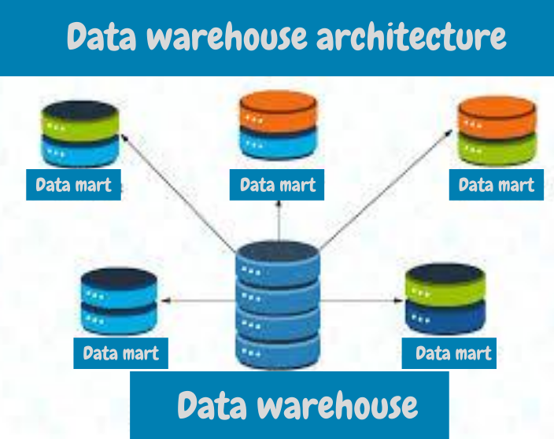

4. Operational Data Store

Acts as an intermediate between transactional systems and data warehouse (operational reporting)

5 .OLTP vs Warehouse Applications

OLTP systems are designed for realtime, high volume transaction processing, while data warehouses focus on analysing historical data for business intelligence

6. Data Marts

The Data in the data warehouses stored in the form of data marts,data mart is the subset of data warehouse

7. Data Marts vs Data Warehouses

A data Warehouse is a central repository of data from various sources, designed for company-wide analysis and reporting

A Data Mart is a subset of a data warehouse, focused on a specific subject area or department within an organization

8. Data Warehouse Life Cycle

The stages from initial conception to retirement, including requirements gathering, design, development, testing, deployment, operation and maintenance